Shropshire and Telford & Wrekin Local Maternity and Neonatal System

End of Year Report 2019/20

- Introduction

This report shares with the Board members the current performance metrics resulting from the work of the Local Maternity & Neonatal System (LMNS) and the projects undertaken during 19/20.

- Background

Following the publication of the national review of maternity services (Better Births 2016); a transformation plan for maternity services in Shropshire and Telford & Wrekin has been developed through the Shropshire and Telford & Wrekin Local Maternity System (now known as Shropshire, Telford and Wrekin Local Maternity and Neonatal System). The plan sets out how transformation will be achieved in line with the requirements of Better Births which are to;

Improve choice and personalisation of maternity services so that:
- All pregnant women have a personalised care plan;
- All women are able to make choices about their maternity care, during pregnancy, birth and after their baby is born;
- Most women receive continuity of the person caring for them during pregnancy, birth and after their baby is born;
- More women are able to give birth in midwifery settings (at home and in midwifery units)

Improve the safety of maternity care so that all services:
- Have reduced rates of still birth, neonatal death, maternal death and brain injury during birth by 20% and are on track to make a 50% reduction by 2025
- Are investigating and learning from incidents and sharing this learning through their LMNS and with others;
- Are fully engaged in the development and implementation of the NHS Improvement Maternity and Neonatal Quality Improvement Programme.

- Transformation Trajectories

The 19/20 performance and transformation trajectories against the Better Births priorities are provided in the table below.

KLOE | 2019/20  Target | 2020/21  Target | 2021/22  Target
Stillbirths | 3.2/1000  (16) | 3/1000  (15) | 2.8/1000  (14)
Neonatal Deaths | 1.2/1000  (6) | 1/1000  (5) | 1/1000  (5)
Brain Injury | 1.8/1000  (9) | 1.7/1000  (8) | 1.5/1000  (7)
Personalised Care Plans | 0 | 100% | 100%
Three Places of Birth | 100% | 100% | 100%
Continuity of Carer | 20% | 35% | 51%
Births in Midwifery Settings | 17% | 20% | 25%

The requirement to improve the access to specialist Perinatal Mental Health services is also included in Better Births. This will contribute directly to the key objective of enabling 30,000 more women each year to access appropriate specialist treatment and support by 2021, reducing the unacceptable variation in access to high quality care.

This report sets out in more detail the current position and outlines key activity required in order to meet the onward trajectories.
Reducing Stillbirths, Neonatal Deaths and Brain Injury
It should be noted, that due complexities in pathways, differences in definitions and reliance on external sources for validated data, several data sources need to be explored in order to understand performance in relation to Stillbirths, Neonatal Deaths and Brain Injury for the LMS.
The LMS has access to data held by Shrewsbury and Telford Hospitals Trust (SaTH) in relation to Stillbirths, Neonatal Deaths and Brain Injury occurring within SaTH. However, some babies born to mothers registered with a Shropshire or Telford and Wrekin GP will receive some of their care outside of the LMS area. Therefore, some stillbirths, neonatal deaths and brain injuries in relation to Shropshire, Telford and Wrekin will not be included in the SaTH data. Likewise, the SaTH data will include babies born to mothers who are registered with a GP outside of Shropshire, Telford and Wrekin. The most recent data showing stillbirths and neonatal deaths by STP area relates to 2018 activity and was published in 2020 by ONS. More in-depth comparative data is published by MBRRACE with the most recent publication in 2019 relating to 2017 activity.
The most recent local data available is the SaTH data which may not include all Stillbirths, Neonatal Deaths and Brain Injuries relating to Shropshire and Telford & Wrekin patients.
SaTH data (Maternity Dashboard presented to CQRM April 2020) shows that from April 2019-March 2020 there were 14 stillbirths. This equates to a rate of 2.8:1000. This indicates that the LMS target for 2019/20 was achieved.
The table below includes data from the West Midlands Neonatal Operational Delivery Network in relation to Neonatal Deaths and Brain Injury for Shropshire, Telford and Wrekin Patients who had a neonatal stay in the West Midlands.
2019/20 Neonatal Deaths and Brain Injury

Shropshire, Telford and Wrekin Babies who were booked at SaTH and had a neonatal admission (not necessarily at SaTH | 813
Neonatal Deaths | 8
Babies with a diagnosis of HIE (indicator of Brain Injury) | 6 (one of whom sadly died before discharge)

Saving Babies Lives Care Bundle (SBLCB)
The Saving Babies’ Lives Care Bundle has been produced to provide detailed information for providers and commissioners of maternity care on how to reduce perinatal mortality across England. The second version of the care bundle brings together five elements of care that are widely recognised as evidence-based and/or best practice:
- Reducing smoking in pregnancy
- Risk assessment, prevention and surveillance of pregnancies at risk of fetal growth restriction (FGR)
- Raising awareness of reduced fetal movement (RFM)
- Effective fetal monitoring during labour
- Reducing preterm birth (This is an additional element included in version 2 of the care bundle in response to The Department of Health’s ‘Safer Maternity Care’ report).

SBLCBv2 includes sections which reference the importance of other interventions outside of the remit of the care bundle, such as continuity of carer models, following NICE guidance, delivering ‘healthy pregnancy messages’ before and during pregnancy and offering choice and personalised care to all women. These are not mandated by the care bundle but reflect best practice care and are recommended to be followed in conjunction with the care bundle.
Implementation of the care bundle was included in the NHS planning guidance and incorporated into the standard contract for 2019/20.
Full implementation of SBLCBv2 is key to ensuring that there continues to be a reduction in the rate of stillbirth, neonatal death and brain injury and there was a national commitment to have fully implemented SBLCBv2 by 31 March 2020. In February 2020 following a gap analysis undertaken in partnership with the West Midlands Maternity Clinical Network, the LMNS Programme Board noted that full implementation of Saving Babies Lives Version 2 would not be fully evidenced by March 2020 –therefore falling short of the national recommendation.
During 2019/20 the LMS supported the implementation of SBLCBv2 in range of ways, these are summarised below.
Clinical Network Gap Analysis
Through the LMNS, the West Midlands Maternity Clinical Network supported SaTH in undertaking a gap analysis in relation to compliance with the requirements of Saving Babies Lives Care Bundle Version 2. A series of recommendations were made to support full implementation of the care bundle, including that the clinical network continue to support SaTH.

Training for staff
The LMNS received funding of £10,000 to support the implementation of the care bundle. The funding was used for Doppler Screening training for midwife sonographers, a Baby Lifeline CTG master class and Human Factors training which included situational awareness and group thinking. It should be noted that due to COVID-19, the Human Factors session has not yet occurred and will be re-scheduled to take place 2020/21.

Co-production of local plan
The LMNS funded a Saving Babies Lives event, which took place on 27th February 2020. The objectives of the event were to support the development of a local plan to deliver a reduction in still births, neonatal deaths and severe brain injury by 50% by 2025. The morning consisted of celebration and information provided by a number of high profile speakers, followed by lunch and networking opportunities. The afternoon session was dedicated to working in co-production in order to develop a plan for reducing stillbirths, neonatal deaths and severe brain injury further over the next 5 years. 114 people attended which included:-
- Women and their families
- Midwives
- Consultant Obstetricians
- Health Visitors
- Neonatal Staff
- Public Health professionals

The workshop discussions from the event have been collated and transferred and will be developed into a local Saving Babies’ Lives action plan to be taken forward by the Local Maternity and Neonatal System. The development of the plan has been delayed due to COVID-19 and will be undertaken during 2020/21.
Reducing smoking in pregnancy

The LMNS has acknowledged that reducing smoking in pregnancy rates is a key priority in relation to reducing stillbirths, neonatal deaths and brain injury. The Smoking at Time of Delivery Rates within SaTH for 19/20 were 13.3% overall, 11% for Shropshire CCG and 15.4% for Telford and Wrekin CCG. There has been a reduction overall against 18/19 figures which were 16.5%. The smoking at time of delivery rates for Shropshire, Telford and Wrekin patients across all providers in given in the table below:
Smoking at Time of Delivery 2019/20
 | Q1 | Q2 | Q3 | Q4 | Full Year
Shropshire CCG | 10.92% | 10.04% | 11% | 11.4% | 10.83%
Telford and Wrekin CCG | 15.4% | 16.1% | 14% | 15.9% | 15.4%
Overall |  |  |  |  | 12.83%

Smoking in pregnancy rates are still higher in Shropshire, Telford and Wrekin than the national average and there is some way to go until the target within the Tobacco Control Plan is met; To reduce prevalence of smoking in pregnancy to 6% or less by 2022.

An increase in Carbon Monoxide monitoring and earlier access to services and increased support is likely to have a big impact in reducing smoking at time of delivery rates.
The LMNS has funded increased capacity specifically for smoking in pregnancy support, through a Band 5 role to support the Public Health midwife for a period of 12 months. This commenced during July 2019.
Enhanced training has been made available through the LMS for those working in maternity services in order to ensure that midwives, women’s support assistants and others have up to date information in relation to the risks associated with smoking in pregnancy and are confident in explaining these to women and their families in a way that will have maximum impact. It is important that those working in maternity services are enabled to attend such training.
Work is on-going to better understand how to most effectively reduce smoking in pregnancy rates. The NHS Long Term Plan includes a commitment to reduce smoking rates, including smoking in pregnancy. The NHS Long Term Plan Implementation Framework includes reference to indicative funding allocations for all STPs and ICSs, from 2021/22, for the phased implementation of NHS smoking cessation services for all inpatients who smoke, pregnant women and users of high-risk outpatient services (as a complement not a substitute for local authority’s own responsibility to fund smoking cessation) (NHS Long Term Plan Implementation Framework page 15).
During 2019 Shropshire and Telford & Wrekin local authorities undertook a service review on the current smoking cessation services across the County. At the December 2019 LMNS Programme Board a service model recommendations paper was presented with the findings. A further paper was then presented at the LMNS Programme Board in February 2020 with costing information for the Shropshire, Telford & Wrekin wide maternity-based smoking in pregnancy (SiP) service. LMNS funding has not yet been confirmed for this bid.
Concerns were raised at LMNS Programme Board in relation to the uncertainty around funding and commissioning responsibility for smoking cessation services and the negative impact that this could have on smoking in pregnancy rates in Shropshire, Telford and Wrekin.
Raising awareness of reduced fetal movement

During 2019 the pilot of a bracelet designed to help women to be aware of their baby’s movements was undertaken. 1000 bracelets were given out to women across the county who were 28+ weeks gestation. Feedback was gathered and the design of the bracelet was amended based on the feedback received from women. This new design was approved by SaTH Maternity Governance and bracelets are now being given out to all women who are booked to give birth in Shropshire, Telford and Wrekin.
The manufacturers of the bracelet (Davidov London) have also created a version of the bracelet known as the ASKA Maternity Movement Bracelet. The bracelet has been launched globally and has also featured in the Hello and OK Magazines. A percentage of the sales will be received back into NHS Telford and Wrekin Clinical Commissioning Group to further support this and similar local initiatives.
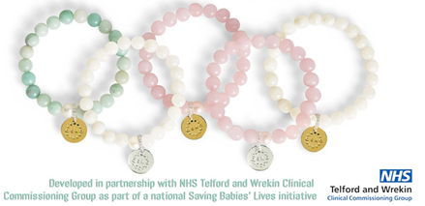
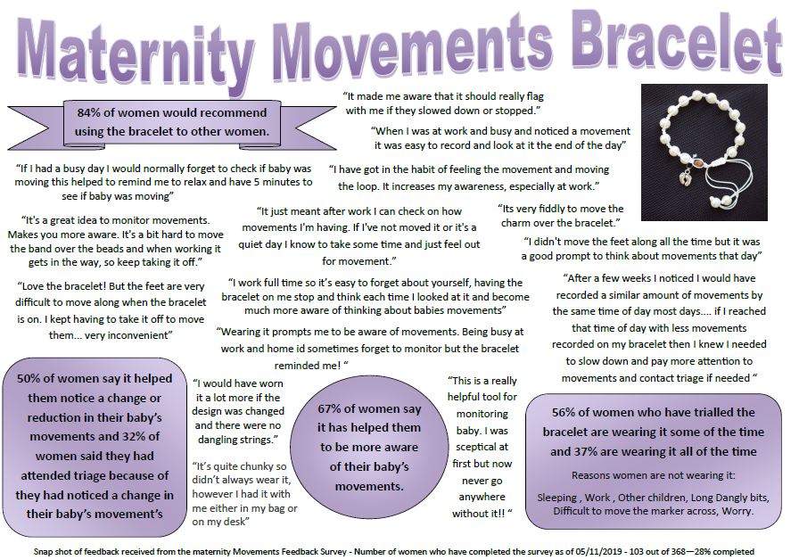

Baby Buddy App
The LMNS Programme Board approved for funding to be allocated to promote implementation and localise the ‘Baby Buddy’ app. This app and website has been funded by the Department of Health. Baby Buddy is the multi-award winning free app that guides you through pregnancy, birth, parenting and beyond. https://www.bestbeginnings.org.uk/baby-buddy
It covers many areas such as:
- Being healthy inc. smoking, alcohol, perinatal mental health, drugs, breastfeeding, exercise etc…
- Pregnancy
- Baby movements
Through LMNS funding, targeted messages were sent out through the Baby Buddy app to women at 28 weeks of pregnancy during 2019, reminding them of the importance of monitoring their baby’s movements. Information around reduced fetal movements has also been promoted through the Maternity Voices Partnership (MVP) social media pages.
The number of Baby Buddy app downloads has increased from 1786 to 3952 across Shropshire and Telford and Wrekin during the period of 1st April 2019 to 31st March 2020.
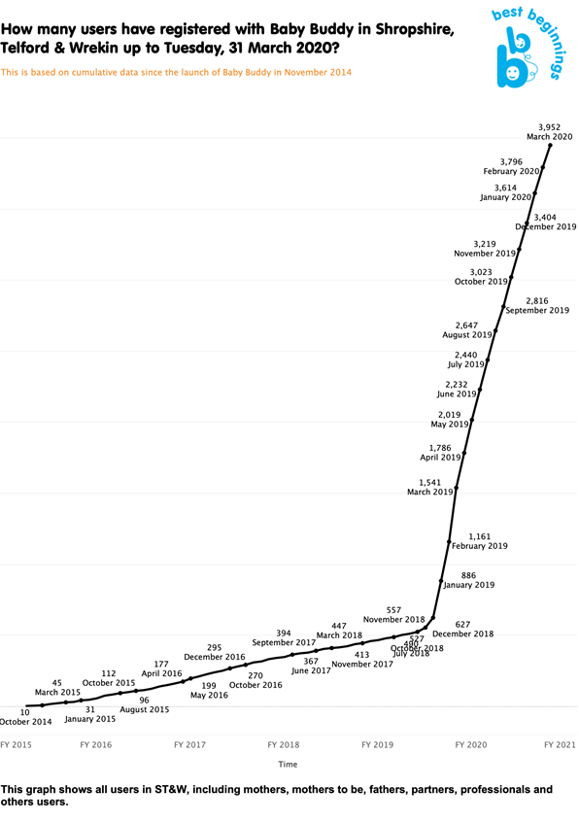

Best Beginnings (the providers of Baby Buddy) provide a quarterly report providing full information on downloads for areas across Shropshire, Telford and Wrekin including the number of videos that have been watched, which videos have been the most popular, what questions people have asked and feedback from women around whether the app has supported them through pregnancy.

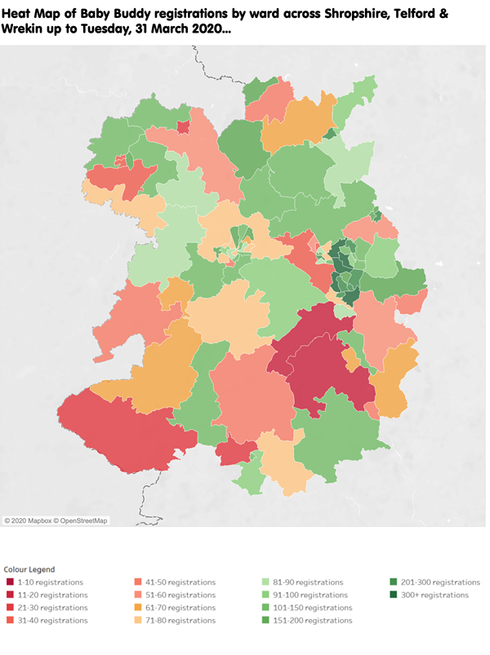
Through the LMS, two Baby Buddy promotional events took place on the 23rd October 2019 in Dawley (Telford) and Radbrook (Shrewsbury) where over 100 health professionals and women and their families came together to learn more about the Baby Buddy App and celebrate our local success.

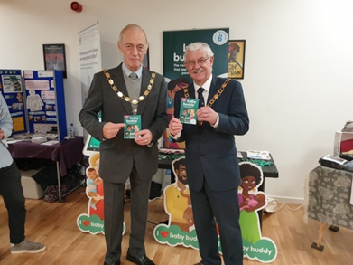
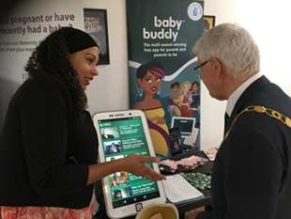
We were also visited by the Mayor of Great Dawley and the Mayor of Telford and Wrekin who were really interested in finding out more about the app.
Personalised Care Plans (PCP)
Through the Maternity Voices Partnership, the existing hand held records were reviewed and improvements recommended to support collaborative planning between health professionals and women receiving maternity services. A personalised care plan has not yet been finalised or implemented. However, the Transformation Midwife leading on Antenatal Pathways is now driving this forward and we remain on track for full implementation by March 2021. The LMNS and MVP are working on a short term solution until the new Maternity Information IT system called Badgernet is implemented within SaTH which provides an integrated electronic PCP.
The LMNS was awarded funding as part of workforce development transformation funding across Midlands and East to specifically support maternity projects and workforce transformation. With this funding the LMNS commissioned an external company to undertake some Motivational Interviewing (MI) which is a technique to facilitate behaviour change by drawing out women’s own motivations and goals, rather than imposing those of the health professional. This was commissioned in order to support personalised care planning.

It places greater importance on autonomy and the techniques out-perform traditional advice-giving in terms of improving health behaviours and adherence to recommendations. It has been shown that the effects of having a conversation in this way persist even when used in brief consultations and is easily adapted for use by all health care professionals and non-clinicians.

During 2019/2020 174 staff attended this training across the LMNS with extremely positive feedback received. Further sessions are planned for 2020.
A full evaluation of the sessions that have taken place is available by contacting Betterbirths.stw@nhs.net
Three Places of Birth
Better Births requires women to have access to at least three of the four birth settings (Consultant Unit, Alongside Midwife Led Unit, Freestanding Midwife Led Unit and Home Birth).
Women in Shropshire, Telford and Wrekin are able to access three birth settings in the LMNS area at the moment whilst Shrewsbury MLU is closed for essential maintenance work. When Shrewsbury re-opens in 2021 women will have a choice of four birth settings. The proposals as part of the review of midwifery care do not impact upon this key line of enquiry, as the proposals include all four birth options within the county.

Continuity of Carer

Research shows that continuity of carer improves outcomes for women and their babies. Women receiving continuity of carer are 16% less likely to lose their baby and 19% less likely to lose their baby before 24 weeks. In addition, women receiving continuity of carer are 24% less likely to experience pre-term birth. However, implementing this new way of working in line with the nationally set targets has been a challenge and the target of 20% women receiving continuity of carer by March 2020 was not achieved.
The continuity of carer LMNS targets have been included in the Long Term plan. In addition, the NHS long term plan states that by 2024, 75% of women from BAME communities and a similar percentage of women from the most deprived groups will receive continuity of care from their midwife throughout pregnancy, labour and the postnatal period.
A number of engagement activities took place throughout 2019 with staff to raise awareness of the benefits of continuity of carer and to discuss potential challenges and identify solutions to these.
Our LMNS was also awarded funding from HEE to deliver Continuity of Carer training. This was delivered by North West London Collaboration of Clinical Commissioning Groups during May 2019. The training covered:-
- Understanding what is meant by continuity of carer and the research evidence
- To be able to work effectively in a team or with a buddy to provide continuity of carer antenatally, during labour and postnatally
- To understand how to lead a team to successfully implement continuity of carer
- To be able to asses implementation

In January 2020 a Transformation Midwife was appointed through LMNS funding to lead specifically on the implementation of Continuity of Carer. Two continuity of carer teams have been identified and once in place will enable approximately 10% women to receive continuity of carer. A further 5 teams will need to be established to meet the 35% target for 2021. A total of 11 teams will be needed to enable more than 50% women to be in receipt of continuity of carer.

Significant progress will need to be made in relation to the staff available and willing to deliver continuity of carer models if the trajectories are to be met. Key barriers to date have been in relation to:
- Staffing numbers available to support continuity models of care
- Low staff morale contributing to only small numbers of midwives willing to try new ways of working in order to deliver continuity of carer
- Limited staff engagement in continuity of carer development work
- Capacity of senior midwives to re-configure the workforce in line with continuity of carer models
SaTH have increased midwife numbers, which supports delivery of continuity of carer. However, there needs to be a continued corporate commitment within SaTH to deliver continuity of carer in order to ensure the availability and willingness of midwives to change ways of working in line with continuity of carer guidance.
Births in Midwifery Settings
Births Activity by Unit |  |  | Shropshire  CCG |  | Telford and Wrekin CCG |  | SaTH
Births Activity by Unit |  |  | 2019/20 | 2018/19 | 2019/20 | 2018/19 | 2019/20 | 2018/19
Births Activity by Unit | Total Births |  | 2131 | 2182 | 1997 | 1986 | 4422 | 4511
Births Activity by Unit | Telford CU |  | 1932 | 1926 | 1871 | 1816 | 4086 | 4062
Births Activity by Unit | Shrewsbury MLU |  | 15 | 67 | 0 | 1 | 15 | 69
Births Activity by Unit | Wrekin MLU |  | 123 | 129 | 95 | 140 | 224 | 285
Births Activity by Unit | Home |  | 41 | 44 | 14 | 27 | 56 | 75
Births Activity by Unit | Born Before Arrival |  | 20 | 4 | 17 | 2 | 41 | 8
Births Activity by Unit | % of births in Consultant Unit |  | 90.7% | 88.3% | 93.7% | 91.4% | 92.4% | 90.0%
Births Activity by Unit | % of birth in a MLU or at home |  | 8.4% | 11.5% | 5.5% | 8.5% | 6.7% | 9.8%
Births Activity by Unit | % of births in any MLU |  | 6.5% | 9.5% | 4.8% | 7.1% | 5.4% | 8.1%
Births Activity by Unit | % Home Births |  | 1.9% | 2.0% | 0.7% | 1.4% | 1.3% | 1.7%
 | Shropshire, Telford and Wrekin % of SaTH births in MLU or at Home |  | 6.9%

Source of data – SaTH dashboard submitted to CRQM in April 2020
The Clinical Dashboard from SaTH provides information relating to the vast majority of births for women from Shropshire, Telford and Wrekin. In 2019/20, 9% women from Shropshire, Telford and Wrekin gave birth in other providers, with 4% giving birth in Betsi Cadwaladr (Wrexham) and 5% giving birth in other English providers. Data is not yet available in relation to whether these women gave birth in a consultant led or midwifery setting.

The data for births in-county shows that 6.9% women gave birth in a midwife led setting. This is a decline in performance and significantly below the target set for this year (17%).

This performance needs to significantly improve in order to meet the LMNS trajectories. Through the LMNS work, births in midwifery settings will be increased through:
- Reducing risk in pregnancy to enable a greater number of women to meet the risk eligibility criteria to give birth in midwifery settings.
- Increasing the proportion of women eligible for a midwife led births, who choose to give birth in midwifery settings.
- Improved birth choice information in order that women can make an informed choice.
- Improved birth experience at Wrekin MLU as the LMNS have contributed to a number of new birthing options equipment for women to use.
- Promotion of the new Wrekin MLU and Home Births options.
Births at the Shrewsbury MLU were stopped during 2019/2020, due to essential building maintenance works. This may have contributed to the reduction in number of births taking place in midwife-led settings. Whilst the building works at Shrewsbury MLU are not expected to be completed until 2021, it is anticipated that the new midwife led unit at Princess Royal Hospital will lead to an increase in midwife led births. In addition, the continuity of carer teams are also expected to contribute to an increase in births in midwife led settings.

Through Workstream 2 ‘Healthy Pregnancy, Healthy Families’, work continues to take place with the aim of reducing risk through pregnancy, through initiatives to reduce smoking in pregnancy rates and increase the number of women at a healthy weight during pregnancy. This will also contribute to increasing the proportion of births in midwife led units or at home.

A Birth Choices leaflet has recently been co-produced through the Maternity Voices Partnership to increase awareness of the different birth options for women. This may also help to increase the proportion of women who choose to give birth in a midwife led setting.
Perinatal Mental Health (PMH)
The specialist perinatal mental health service is delivered by Midlands Partnership NHS Foundation Trust and during 2019 there was a significant amount of work which took place to complete and submit a bid in wave 2 of the Perinatal mental health community services development fund. The purpose of the fund is to develop specialist perinatal mental health community services, and increase the availability of high quality interventions and support for women, their babies and families.
Following the bid the new PMH team was implemented during September 2019, however, there have been a number of changes during the year, some difficult challenges to overcome and a consultant psychologist still hasn’t been recruited to on a permanent basis.
Despite the challenges, during 2019/20 279 referrals were received into the service.
During the summer of 2019 Healthwatch Telford and Wrekin undertook a local Perinatal Mental Health exercise to collate research on the following:-

- understand expectations and ideals for mental health and wellbeing before, during and after pregnancy.
- identify what needs are not fully met by the current system and how these could be met.
- Examine which aspects of care are important before, during and after pregnancy so we know what to change and what to maintain for the future.
- Build from scratch a vision of what is desired from the health and care system outside of the constraints of the current system

The results of this exercise were shared with the PMH workstream and the LMNS and MVP will be looking at how this information can be used to improve future services, taking account of the recommendations that were made:

- More support is made available for dads/partners, such as focussed questionnaires and more “male orientated supportive environments” so they are able to talk about their concerns and needs
- Better information for women / partners is provided, including around the pregnancy and birth, breast feeding, mental health and the support available and the referral criteria (e.g. for IAPT2 the Community Mental Health Team, Joint Obstetric Liaison Clinic and PNMH Team) and that this is also available to staff working across the system
- More consistent and face to face contact with professionals is available, including Midwives and Health Visitors, to enable women / partners to feel able to discuss their concerns and ask questions
- More support groups, including focused groups (e.g. for mums with Post-Natal Depression) are set up to help people to build a peer support network
- Mental Health Training is made available to all staff working with women / partners so that conversation about mental health becomes part of day-to-day discussions. This training will enable staff to respond appropriately and make the necessary referrals, in order to prevent conversations feeling like a “tick box exercise”
- The new Perinatal Mental Health Team works closely with GPs and primary care to ensure:
- consistency of advice and prescribing of medication during the perinatal period
- those people who do not meet the criteria to receive support from the Perinatal Mental Health Team are supported appropriately and consistently in primary care
- GPs can help the Perinatal Mental Health Team to engage with women / partners who have been identified as needing support

The West Midlands Maternity Clinical Network commissioned Action on Post-Partum Psychosis to deliver two training sessions in the West Midlands. These sessions took place on the 9th and 16th May 2019 and 7 staff attended for Shropshire, Telford and Wrekin.

Further Post-Partum Psychosis training took place on the 21st June 11th July 2019 which included :-

- A personal account from someone who has experienced Postpartum Psychosis
- Factual information about Postpartum Psychosis
- A guide to appropriate signposting
- Information on the support that the charity Action on
Postpartum Psychosis (APP) offers which includes peer support

21 members of staff across the LMNS attended this training.
The LMNS funded £5,000 for the Recovery College to develop a course in managing perinatal mental wellbeing and illness. The College worked with a number of the Perinatal Team and also recruited two peer trainers to join them to develop the course. Three sessions were planned; all course materials were ready to go and students booked on, but due to COVID19 they had to be cancelled three days before delivery back in March 2020. The course materials do not translate well to an online platform but once face to face to training is resumed they will set up a new time to deliver.
The LMNS funded an expert by experience to set up a drop in session to support women during and after pregnancy. The sessions took place in Woodside (Telford), Shrewsbury and Oswestry on a weekly basis. The aim of the group was to minimise isolation within pregnancy and the postnatal period, increase knowledge of the services available to women regarding perinatal MH and addiction recovery and most importantly, provide a safe space for women to speak about the difficulties they may be experiencing with likeminded women. These sessions started in July 2019 however were not well attended and ceased later in the year. A sum of £3,999 has been recovered back into the LMNS for sessions not delivered.
Caroline Thorp, Nurse Consultant at Brockington Mother & Baby Unit was commissioned by MPFT to deliver a number of awareness sessions on Perinatal Mental Health across Shropshire, Telford and Wrekin for staff. A large number of staff attended these sessions and the feedback was very positive.
The LMNS funded the annual Public Health Study day which took place on 12th September 2019 where a number members from the PMH workstream supported on the day as the morning session focused on perinatal mental health.

A number of health professionals attended and received presentations on:-

- MBRRACE
- An Overview of Perinatal Mental Health
- Prescribing in Pregnancy
- Eating disorders in pregnancy
- Puerperal Psychosis
- Healthwatch Shropshire
Health professionals also had the opportunity to meet the new Perinatal Mental Health team which launched on 30th September 2019 and network with a number of organisations which hosted information stands. Feedback from the day was very positive.
On the 15th November 2019 Healthwatch Telford and Wrekin delivered a PMH workshop on behalf of the LMNS to talk about how access to information could be improved across the County. The group was well attended by MVP members and health professionals with an interest in PMH.
Additionally Healthwatch Shropshire attended an existing breast feeding group in Oswestry on the 22nd November 2019 to gather the same information around PMH.
Postnatal Improvement Plan
The LMNS funds a Transformation Midwife who leads on the development and implementation of the Postnatal improvement plan, in line with the national direction which advises that postnatal improvement plans should cover how women (and their families) will:
- be provided with personalised, kind care in the postnatal period.
- receive effective transfer of care and quality information when returning home.
- be supported in their return to physical health, including follow-up of
complications in pregnancy and clear pathways for referral when issues are
identified.
- be supported to successfully feed their babies, including a tailored
breastfeeding strategy across the LMS.
- receive improved mental health assessment, identification, and access to
emotional and mental health support, including for bereavement and when
babies need neonatal care.
- receive seamless care between midwifery, health visiting and general practice.

A postnatal improvement plan for Shropshire, Telford and Wrekin was developed in co-production and was submitted in March to NHS E/I for implementation throughout 2020/21.

Digital
Through LMNS funding of £120,000, digital devices were purchased to enable community midwives to better access systems and data in the areas in which they work. Unfortunately, limited progress has been made in making the best use of these devices.
The existing electronic maternity system used within the provider Trust does not facilitate the use of effective digital technology and data. Key to digital transformation in local maternity services is the implementation of a new electronic system for maternity services within the provider Trust.

Workforce
Shrewsbury and Telford Hospitals Trust (SaTH) is the sole provider of maternity services within Shropshire, Telford and Wrekin. Therefore, the LMNS is reliant on SaTH to fully implement the elements of the transformation agenda that relate to maternity providers. The LMNS recognises the pressure that the workforce is under, not least due to the external pressures from CQC, and the independent review, led by Donna Ockenden into cases of serious and potentially serious concern at SaTH. As such, the ability of the existing workforce to deliver the transformation required is of concern to the LMNS Programme Board.
In 2017 SaTH undertook a Birthrate Plus maternity workforce assessment and during 2019/20 recruited an additional 29 midwives in line with the recommendations. A further Birthrate Plus assessment is due to take place in 2020/21 to ensure that the workforce levels remain in line with Birthrate Plus recommendations. Following this a reviewed workforce plan will be presented to LMNS Programme Board which will outline any further changes required such as impact of introducing the Continuity of Carer model and introduction of Band 3 Support Workers. It is recognised that transformation cannot happen with an increase in staff numbers alone. The age profile of existing workforce remains a risk, however SaTH is looking at ways to retain staff either through the yearly cohort of student nurses being recruited and offered preceptorships or as part of the wider retire and return strategy in order to retain skills.
A number of staff have attended training opportunities funded through the LMS to improve outcomes and experience for women and their families, including:-
- Shared Values based conversation train the trainer course
- Hypnobirthing
- Aromatherapy
- Baby Buddy
- Waterbirth study day
- Motivational Interviewing

Further training opportunities will be available during 2020/21 such as motivational interviewing, smoking in pregnancy, in house aromatherapy, biomechanics and in house hypnobirthing.

Maternity Voices Partnership (MVP)
The development of the MVP has been really successful during 2019/20. The end of the year saw the recruitment of a service user chair, 2 vice chairs and a number of volunteers hosted through Healthwatch Telford and Wrekin. This is a fantastic development and will enable co-production to be far more embedded in business as usual as we move forward. Having volunteers out in the communities will also mean they are able to do targeted engagement with local groups with a specific focus on the seldom heard groups such as young mums, BAME populations, mums with disabilities and dads/partners. It is important to have these volunteers working across the county to ensure all corners of the county are heard as topics that come up may differ from area to area.
Social media continues to be an effective way to engage women and their families. The MVP social media accounts have grown considerably through 19/20. At the end of 2018 we unfortunately lost access to the original MVP Facebook group which had a quite considerable following. At the beginning of 2019 we managed to set up the new Facebook page and by the start of the 19/20 year we had around 160 people liking our page and following what we were doing. By the end of March 2020 we had around 800 likes which is a considerable increase in people following what we do. Our Instagram was set up April 2019 and is not as successful as the Facebook page but still has a small following and is another way to reach out to people who are interested in what we do. Our Twitter account was set up in 2018 and continued to grow slowly throughout 19/20.
The MVP supported the promotion of a number of campaigns throughout 2019/20 including Baby Buddy, Reduced Fetal Movements, Healthy Pregnancy and Red Hats. Service users also continue to be involved in the review, revision and development of information for service users and their families.
Specific areas of focus for the MVP during 2019/20 included:
- Perinatal Mental Health
This has had a large focus throughout the year with many different messages being shared and also sharing information on the new support services and peer support group that was set up. MVP were also represented on Perinatal Mental Health Focus Groups , including a focus group which bought together professionals and service users to discuss the current perinatal mental health service and how it could be developed.

- Wrekin MLU/New MLU at PRH
As part of the initiatives to increase midwife led births, service users worked alongside staff to help in making improvements to the look and feel of Wrekin MLU and also informed the design, décor and equipment in the new MLU at Princess Royal Hospital.
- Home Birth Focus Group
Service users came together with the newly formed homebirth team to discuss the new service and how it should be rolled out and promoted
- Transforming Midwifery Care (TMC)
A number of events were held which the members attended and participated in. These members then worked with the TMC team to develop a TMC focus group who were used to help proof read documents as they were developed.

- Planning for a healthy pregnancy

Service users joined professionals to discuss how we could develop and promote Planning for a Healthy Pregnancy. This was very successful and managed to contribute ideas that will be developed to help support families to plan for and have a healthier pregnancy.

- Postnatal Improvement Plan

Service users attended the plan development session and continue to be involved in
postnatal improvement plan activity.

- Saving Babies Lives
Through attendance at the Saving Babies Lives event, service users shared valuable contributions towards the development of the 5 year plan to further reduce stillbirths, neonatal deaths and brain injury.
- 15 Steps to maternity
On the 23rd August 2019, we held our first 15 Steps to maternity event at the Wrekin
Midwife Led Unit. This was attended by 4 service users plus 2 members of staff and 2
LMS programme staff. Comments and recommendations from the 15 Steps event
were discussed and included in the planning of the new unit. The plan was to revisit
the new unit once open and complete a follow up 15 Steps but this was postponed due
to COVID-19.

The full MVP Annual Report can be requested by emailing maternity.voices@nhs.net

Transforming Midwifery Care (TMC)
Following the significant amount of work undertaken in 2018/19 for the review of midwifery care, the proposals were presented to and endorsed through local and regional governance processes. In November 2019 the proposals were presented to the NHS E/I Oversight Group for Service Change and Re-configuration (OGSCR). The feedback received was positive and noted that ‘national colleagues were impressed by the rigour and attention to detail’ in the proposals. It was anticipated that the proposals would be taken forward for approval at the NHSE/I National Assurance Panel on 28th November 2019. This was delayed and the proposals have not yet been presented to the National Assurance Panel for approval to go out to consultation.
This significant delay means that the instability in service provision and inequity in access to services for women and their families continues. In addition, we are no further forward in realising the proposed improvements in relation to clinical effectiveness and safety for women accessing midwifery care in Shropshire, Telford and Wrekin. More recently, developments in relation to elements of the Neonatal Critical Care Review and Maternal Mental Health services are hindered by the lack of maternity hubs – which are a key part of the Transforming Midwifery Care proposals.

Local Maternity System Transformation Team
During September 2019 The Local Maternity System Team was awarded the Star Team Award at the Telford and Wrekin CCG Staff Awards. They were nominated because “NHS organisations, Healthwatch and local councils are working together as an LMNS to design and implement improvements in maternity and neonatal services”.
The award was collected by Helen White and Louise Macleod on behalf of the team at the Telford and Wrekin CCG Annual General Meeting.
The Team was recognised to have generated innovative transformational and innovative solutions to help improvement maternity outcomes for women and their families under the leadership of Fiona Ellis, Programme Manager for the Shropshire Telford and Wrekin LMNS.
The Maternity Transformation Team were also nominated in the Star Partnership Category because the “Team has worked tirelessly to improve the lives of local pregnant women” and have helped with “delivering a number of events where health professionals and women and their families have come together to share experiences and to discuss improvements to the service” They have managed the “Implementation of the Baby Buddy App.” and “staff have benefitted from training with other organisations and have received a greater understanding of each other’s roles in respect to a women's journey.” “Women and their families are also feeling the benefits of partnership working - they feel more empowered and involved in improvements and feel that their voices are being heard.”
We are immensely proud of this award and also being nominated for the partnership award. We would like to thank everyone who is involved in the Local Maternity System, as this award represents the hard work and determination of everyone involved.
Well done to all involved and we are looking forward to continuing the great work.
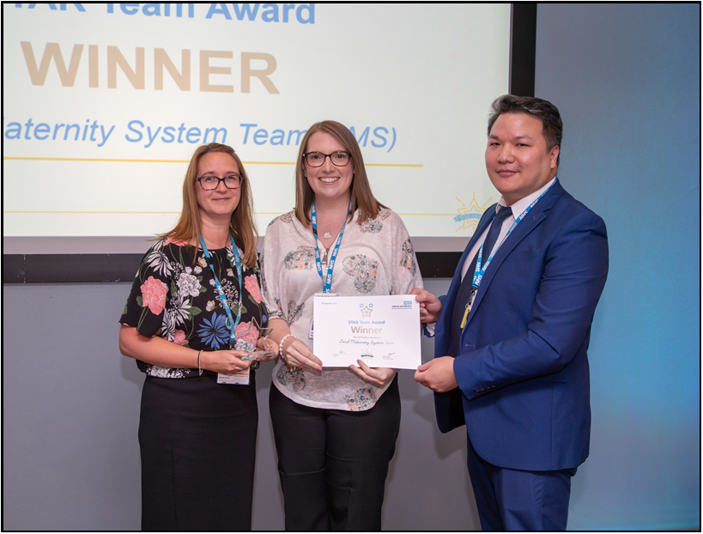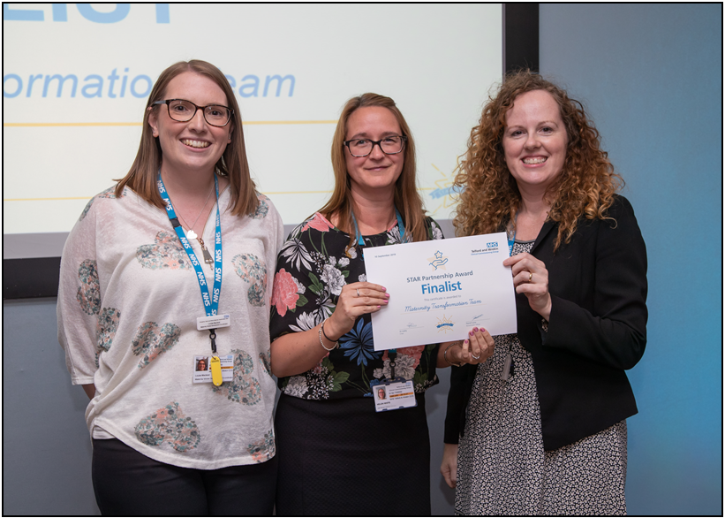
Other Events
The LMNS team hosted a MVP/LMNS/Baby Buddy stall at the Shropshire Baby and Toddler event which took place on the 06th October 2019. We spoke with over 100 women during this event and delivered some live demonstrations of the app.
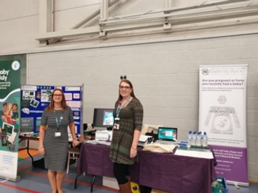

We also attended Healthwatch Telford and Wrekin Annual General Meeting to promote the good work of the LMNS and MVP.

Health TV
The LMNS funded 50 “TV screens” across the county of Shropshire to play a number of Baby Buddy Videos to specifically promote our local campaigns for one month. These include reduced fetal movements awareness, smoking in pregnancy and home births.

Funding
During 2019/20 LMNS was awarded additional one off funding for the following projects:-
- £30,000 from NHS England/NHS Improvement which will be used to support local improvement plans for postnatal care. We will be using this funding to implement a tailored breast feeding strategy to ensure that women have the information and support that they need to successfully breast feed their babies.
- £25,000 HEE funding for smoking in Pregnancy Training
- £10,000 SBL training funding used for Doppler screening , Baby lifeline CTG master class and Human Factor training

19/20 Summary of expenditure
Description of Item | Value | Recipient | Comments
Increased resource within provider trust | £30,000  £67,517 | Shrewsbury and Telford Hospitals NHS Trust | £30,000 for Band 4 Breast feeding peer support worker (Postponed due to COVID) &  three Transformation midwifes from January to end of June (paused due to COVID)
Pump prime digital transformation | £120,000 | Shrewsbury and Telford Hospitals NHS Trust | Devices for community midwives at SaTH
Communications and Engagement | £31,428 | Multiple recipients | MVP, events, hospitality, designing of leaflets and printing
Workforce Development | £29,477.06 | Expectancy  Etal  Hypnobirthing | Motivational Interviewing  Aromatherapy  Hypnobirthing  Training postponed due to COVID – arranged for next year
Improvements to facilities at Wrekin | £1,146.06 | Shrewsbury and Telford Hospitals NHS Trust | Purchased sofas for the new MLU Day room
Peer Support for women who set a quit date for smoking | £32,400 | Home Start Telford and Wrekin | We are currently working with Home Start Telford and Wrekin to progress the pilot.
Other | £28,800 | Fay Baillie HealthCare Solutions | To commission FB HealthCare Solutions to provide the CCG/LMS with Professional Midwifery advice.
Other | £551.00 | Shropcom | CO Monitors purchased and in use
Other | £24,731.25 | SaTH | Bilicocoon phototherapy bag system  purchased and in use on NNU
Other | £4,000 | Shropshire Council | Online Parenting course license purchased and women accessing
Social Prescribing | £65,000 | Telford and Wrekin Council | Postponed due to COVID – discussions have restarted with the council

Actions from 19/20 to be carried forward to 20/21
Number | Action
1. | Finalise and Implement the SBL action plan
2. | Staff to be released to attend smoking cessation training
3. | Human Factors session has not yet occurred and will be re-scheduled to take place 2020/21.
4. | Review the costings for maternity based smoking in pregnancy services and support the preferred system-wide, maternity services embedded model
5. | Identify appropriate funding streams to enable a system-wide model to be funded
6. | Public Health messages to be continue to be shared across the LMNS
7. | Continued raising awareness of reduced fetal movements
8. | Health Professionals to receive training on Baby Buddy
9. | Actively promote the use of the app at every opportunity
10. | Complete essential remedial works to Shrewsbury MLU
11. | Continue to work with Public Health around healthy pregnancy initiatives
12. | Implementation of a PCP and Badgernet
13. | Implementation of the postnatal improvement plan
14. | Re-configuration of staffing to enable continuity of carer to be rolled out in line with national targets.
15. | Recruit to the consultant Psychiatrist post on a permanent basis
16. | The Recovery College to deliver face to face to training once COVID19 restrictions are eased
17. | Raising awareness of perinatal mental health, support and services available
18. | Explore and scope how we can implement LTP Recommendations
19. | Improve access to Medway for midwives working away from SaTH buildings
20. | Development of workforce plan to include system wide approach
21. | Commitment to enable staff to be released for training and development relating to maternity transformation
22. | Commitment to implement Birthrate Plus recommendations
23. | Reconfiguration of staff to enable CofC
24. | Deliver further training opportunities to staff such as motivational interviewing, smoking in pregnancy, in house aromatherapy, biomechanics and in house hypnobirthing
25. | To continue to participate and successfully complete the NHS Assurance Process
26. | Commence the consultation
27. | Analyse the results of the consultation and present the outcome for consideration

