Midlands Region Support Pack
for GP Practices Re-starting
Annual Learning Disability Health Checks

NHS England and NHS Improvement

Annual Health Check Support Pack Content:

- Annual Health Check Rationale

- Prioritising Patients - Risk Assessments

- Prevalent Health Conditions:

- Epilepsy
- Respiratory Disease
- Dysphagia
- Constipation
- Diabetes
- Mental Health Problems
- Dementia
- Physical Deterioration

- Model of Care

- Mental Capacity Act

- Increasing uptake of Flu Vaccination in
people with a Learning Disability

- Funding

- Further Support, Information and Links

- Contact Us

- Annual Health Check Rationale

- It is important to re-start the annual health checks for patients with learning disabilities.

- Through the Learning Disability Mortality Review Programme (LeDeR) we know that people with learning disability die up to 30 years sooner than that of the general population of preventable causes.

- We know from the LeDeR Annual Report (2019) that people
with learning disabilities are dying from a range of health inequalities with some of the most common including;
Constipation, Pneumonia and Aspiration Pneumonia, Sepsis, Epilepsy, Dementia, Ischaemic Heart Disease and
Inappropriate use of DNA CPR.

- An Annual Health Check is key to supporting their needs and avoiding preventable deaths.

- This patient group also has lower levels of health literacy
and self-advocacy skills, which is likely to put these patients at greater risk of unintended consequences from the necessary safety measures in place to deal with the
COVID-19 pandemic.

- This information pack is designed to support you to re-start this service. It is not prescriptive; it is a guide and toolkit with some suggestions for ways forward.

- We recognise that all practices are different and that you
are working in several different ways right now.

- We also recognise that you may already have set up a new
system which may be working well.

- Please use the information in this guide to supplement any existing processes that you already have in place.

- Prioritising Patients - Risk Assessments

Broadly, patients can be placed in low, moderate and high-risk groups. These should take into consideration the following:

- Likelihood of deterioration of existing conditions or a missed diagnosis of a new condition based on residency: patients in non-residential settings or with little to no social or health care package should be placed in the high-risk group. These patients are less likely to be shielding, so will generally have fewer problems attending a face-to-face review.

- Likelihood of deterioration based on clinical history: patients with 2+ co-morbidities should be prioritised as high-risk. Clinical judgement will be required dependant on stability of condition, potential polypharmacy problems, lack of compliance with treatment plans and the specific morbidities in the patient record.

- Those at greatest risk should be called first. In most instances, these patients will require a face-to-face review to enable physical examination. The deciding factor will be the judgement of potential harm vs potential benefit.

- Patients in lower risk groups can be assessed using the remote pack and then brought to the practice for a face-to-face consultation by exception, where deemed clinically necessary. Consideration can also be given to online consultations where this is manageable for the patient and where physical examination is not core to assessment.

- There are some specific morbidities of particular concern in this group due to prevalence and/or poorer outcomes than the general population. They should therefore be specifically included in reviewing co-morbidities for this patient group, rather than relying solely on the chronic disease registers associated with QOF and any specific syndromes diagnosed.

- Several Risk Stratification Guides have been developed.
A suggested tool developed by medics in Lancashire can be utilised to aid prioritisation alongside the information above.

See Section 8 below for a copy of this tool.

3. Prevalent Health Conditions

- Epilepsy: Prevalence is x 20 times higher and Public Health England have identified that poorly controlled epilepsy is one of the most common reasons for avoidable hospital admissions. Managing epilepsy well will reduce Sudden Unexpected Death in Epilepsy (SUDEP) https://sudep.org/

- Respiratory Disease: The main cause of death for people with learning disabilities. The 2019 LeDeR Annual Report stated that 24% of deaths of people with a learning disability were due to bacterial pneumonia.

- Dysphagia: Nearly 10% of patients in this cohort have dysphagia. People with learning disabilities often die from choking, chest infections and malnutrition. The 2019 LeDeR Report stated that 16% of deaths of people with learning disability were caused by Aspiration Pneumonia. Please refer to Public Health England’s Department of Health’s reasonable adjustment guidance.

- Constipation: Constipation is common in this group and incidents of bowel cancer much higher. Please see NHS England's Constipation for Learning Disabilities Resources for information for patients and healthcare professionals.
- Diabetes: There is a higher prevalence and earlier onset of type 2 diabetes in this group. Diabetes is harder to manage for people with learning disabilities, and they therefore require more checks and screening.

- Mental Health Problems: These are more common and communication problems make it harder to diagnose and manage.

- Dementia: Diagnosis is aided by regular monitoring and it helps to have continuity of care so that a person’s capabilities can be witnessed over time. People with Down’s Syndrome are likely to get dementia earlier and therefore cognitive baseline assessments should be done from about the age of 30.

- Physical Deterioration: With the closure of day services and other specialised enablement services, patients with learning disabilities are at particular risk of physical deterioration including pressure problems, increased falls and general decreased fitness and mobility problems. Patients coded as frail or with a history of falls should be prioritised.

- STOMP: Medication reviews should form part of an annual health
Check. NHS England have some STOMP Resources available on their website. STOMP is a national project helping to stop the overuse of medication of people with a learning disability, autism or both with psychotropic medicines.
4. Model of Care

The processes in place to manage the pandemic are important. However, it may be appropriate to make reasonable adjustments to these measures for patients with a learning disability or autism. This can include allowing a person with learning disabilities to bring an advocate or carer to a face-to-face appointment, even if patients are generally not permitted to do so as part of social distancing or infection control measures. It is also important to ensure virtual reviews are fully supported with a carer or advocate in attendance who knows the patient (and therefore understands their baseline condition) where required.

We therefore recommend a stepped approach to reviews based on the risk assessments above;

- Patients at greatest risk be reviewed first
- Patients who can safely be assessed remotely should be (Please refer to the supporting information)
- Patients who present a clinical risk at initial review or on completion of health check should be invited to the surgery or offered a video consultation if that medium can be managed by the patient/carer. Video consultation should only be used where physical examination is not core to assessment and where communication skills are good enough to support this method.
- Patients who present a high clinical risk should be invited to the practice for a face-to-face review. Where these patients are shielding or a have a high risk of Covid-19 infection, consideration should be given to on-line consultation and a clinical decision made on the balance of risk and benefit.
Reviews should be conducted in line with the Directed Enhanced Service (DES) specification for Learning Disability Annual Health Checks. The only aspect of DES not expected to be delivered is the physical examination, and only where this would prevent an unacceptable risk and is deemed appropriate for virtual review according to guidance in this document.

If your practice is working as a group, or sharing space, it is reasonable to invite patients to a practice that is not their usual one. It is important that this is very clear for patients and that you ensure they have the necessary information to undertake a journey which may be unfamiliar. Patients attending an unfamiliar setting should be invited to bring someone with them for support.

Please note that the expectation is that all annual health check’s go back to face-to-face appointments once services are being ‘unlocked’ from the pandemic response.

Annual Health Check Model of Care Flow Chart

Send out easy read letter and pre-check health questions to patient and carer
Risk assess patients to prioritise reviews and decide on review format
Annual health check is due

Invite patient for a remote or face-to-face review.
Consider reasonable adjustments including allowing
the patient to attend with a carer or advocate

Receive pre-check health questions and assure the chosen review format is still correct (change from remote to face-to-face if flags are raised)

Complete face-to-face review

Complete remote review. Flags are raised

Complete remote review. No flags raised

Make appointment to have a face-to-face review with the patient and follow the face-to-face flowchart boxes
Flags raised:

Put in place appropriate measures, investigations etc. in line with severity and risk.

Record review in clinical record and make payment submission

No flags raised:
Record review in clinical record and make payment submission

Record review in clinical record and make payment submission

NB. If you do not return the pre-check questionnaire it is important to follow up and make personal contact to ensure problems do not arise.
Remember that Annual Health Checks should follow the PERSONAL principles:
- Person centered and family centered
- Evidence based
- Rights led
- Seeing the whole person
- Open independent and challenging
- Nothing about us without us
- Action focused
- Living life in the Community

5. Mental Capacity Act

When an annual health check is due, please consider whether the person has capacity to consent to the check and use the following as prompt questions:
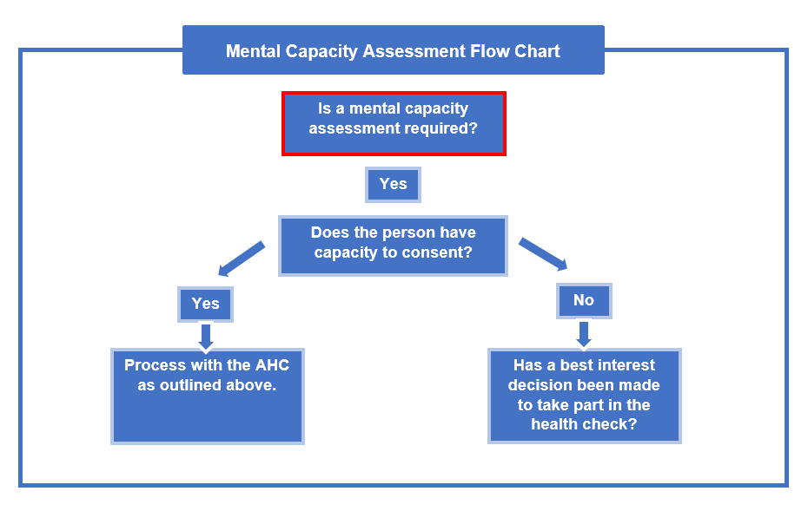
Please note that a best interests meeting may not always be required, but a best interest decision would need to be made where someone lacks capacity to consent, in line with code of practice.
Some further information regarding the Mental Capacity Act is available in easy read here.

6. Increasing Uptake of Flu Vaccination

All patients with a learning disability are eligible for a flu vaccination as per the Green Book Chapter 19 Table 19.4

“Clinical risk groups who should receive the influenza
immunisation.” (Under the clinical risk group Chronic Neurological
Disease). They may equally fit into additional clinical risk groups
such as respiratory disease, obesity or diabetes based on presenting
medical conditions.

We would suggest consideration is given when planning annual health checks across the flu vaccination period, the opportunity is taken to maximise the consultation and complete the annual health check and flu vaccination within one appointment where appropriate. This would support making every contact count and maximise appointment times and reduce
pressure on resources. Within this, the importance of ensuring reasonable adjustments are implemented as required continue to be a priority.

Flu vaccinations can be given as a nasal spray for people with a learning disability if they find injections difficult or distressing. This would be a suitable reasonable adjustment to ensure that they are still able to be vaccinated.

What would also be useful is ensuring any practice publicity around flu either in surgery or on your website, also mentions patients with a learning disability as being eligible.

NHS England & Improvement have produced an Easy Read Flu Poster.

7. Funding

All payments will be made against the usual CQRS submissions according to the terms in the Directed Enhanced Service (DES). Practices can only be reimbursed for the delivery of the annual health checks if the practice meets the legal requirements of the DES Directions. Paragraph 7(g) of the directions describes the minimum criteria for a health check which includes;

A review of physical and mental health which includes;

  - The provision of relevant health promotion advice
  - A chronic illness and system enquiry
  - A physical examination
  - A consideration of whether the patient suffers from epilepsy
  - A consideration of the patient’s behaviour and mental health
  - A specific syndrome check.

The production of a health action plan for all patients with a learning disability who are aged 14 years and over.

A check on the appropriateness of any prescribed medications.

A review of coordination arrangements with secondary care.

Where appropriate, a review of any transitional arrangement which took place on the patient attaining the age of 18.

The critical factor is not the mode of delivery but whether the requirements of the DES directions are being met. The terms of payment are negotiated with the BMA and are not a matter for local determination.

The NHS guidance that was issued in May 2020, highlights that the default expectation is that as we move to restore critical services these reviews will be face to face. However, where there are clinical reasons as to why it would be inappropriate to bring a patient into the surgery, these may be done remotely with as much of the physical examination completed as is possible in the individual circumstances.

Please note that if virtual checks are offered, this must be followed by a physical examination later in the year when it is considered safe to do so.

8. Further Support, Information & Links

Useful Links:

- The MindED Learning Disability and Physical Health Module:
This module aimed at Tier 2 staff and carers.

- NHS England's GP Contract Information
Incudes links to Directed Enhanced Services.

- NHS England’s Improving Identification of people with Learning Disabilities:
This guidance includes information on clinical coding information.

- Mencap’s Patient Information about Annual Health Checks:
This has NOT been updated for the current pandemic.

- NHS Digital Guidance on Learning Disabilities Annual Health Checks
Includes links to payment information and clinical coding.

- NHS England's Mortality Review Report 2019

- Directed Enhanced Service for AHC’s for Patients with Learning Disabilities Supporting documents are included.

- NHS England & Improvement Primary Care COVID-19 Bulletins
You can sign up to receive these regular bulletins for primary care covering all guidance and information published for general practice, pharmacy, dental and optical.

- Learning Disability Matters for Families:
A range of resources have been put in one place to support family resilience and health and wellbeing during COVID-19.

- Royal College of General Practitioners Learning Disability Website:
A range of information from the RCGP can be found on this website about learning
disabilities.

- North Regional Learning Disability & Autism Resources Hub:
Join NHS England & Improvements North Regional Learning Disability & Autism Workspace on Future NHS Collaboration Platform to access our dedicated centralised resource hub on all areas of learning disabilities and autism. This page holds additional local resources for Primary Care in relation to Annual Health Checks

Resources & Information:

- An Easy Read Annual Health Check Invitation Letter:
An example of a letter to invite people to attend
- A Pre-Check Questionnaire Example:
You don’t need to use these pre-check health questions if you have your own in place

- Accessing Services:
An easy read document by NHS England to help people with a learning disability access services during the coronavirus outbreak.

- COVID-19 Information Sharing Guidance:
A letter sent by the Department of Health and Social Care outlining the COVID-19 Notice under Regulation 3(4) of the Health Service Control of Patient Information Regulations 2002.

- Looking After Yourself:
A range of website links to help look after yourself can be found by accessing the document below.

- Lancashire’s Appointment Risk Prioritisation Tool:
A tool developed by medics in Lancashire.

- Saying Goodbye When Someone Dies of Coronavirus:
An easy read guide to support people with a learning disability losing a loved one to coronavirus.

- Mental Capacity Act 2005:
An Easy Read Guide to the Mental Capacity Act 2005.
- NW Covid19 Community Risk Reduction Framework
A framework to help local partnerships reduce the risk of transmission and impact of Covid19 on local communities.
- Workforce - PH outcomes
A resource guide for all health and social care staff
- Annual Health Check Videos:
Videos have been developed by Hull CCG and Leeds & York PFT to help to increase the uptake of checks in their areas.

- A Guide to Swabbing:
Leeds Teaching Hospital’s swabbing easy read guide.

- NHS Northern Cancer Alliance
A number of cancer resources have been produced with people with a learning disability, including a number of videos.

- North West Pathway Associates:
Some fantastic resources on health conditions and health checks are on Pathway’s website as well as some useful links.

- Sunderland Action for Health:
Sunderland’s Action for Health website contains links to accessible Health Information, Health Action Plans, Professional Resources, Screening and much more.

- Get Together Leeds GP's and Practice Staff Resources:
Get Together Leeds have some resources for GPs around Annual Health Checks and other health related topics

9. Contact Us

If you have any questions on this support pack, or on annual health checks
for people with learning disabilities, please email the Midlands Regional
Learning Disability & Autism Team via E: england.midlandsldautism@nhs.net

